Introduction to Cross Tabs
Most beginning Crystal Reports users will ignore the cross tabs feature. They are liable to pay special attention to cross tabs if they have background in pivot tables in Microsoft Excel.

This appendix will cover 3 elements of cross tabs. We cover three major areas with cross tabs in this article:
- Getting data into the cross tab
- Formatting
- Advanced cross tab features.

Getting Data Into The Cross Tab
- Go To The Section Expert – Highlight Group Header #1 A and Choose To Insert a new Group
- Using the arrows move the new group above the previous Group in the List – click OK
- It will look like this in Section Expert
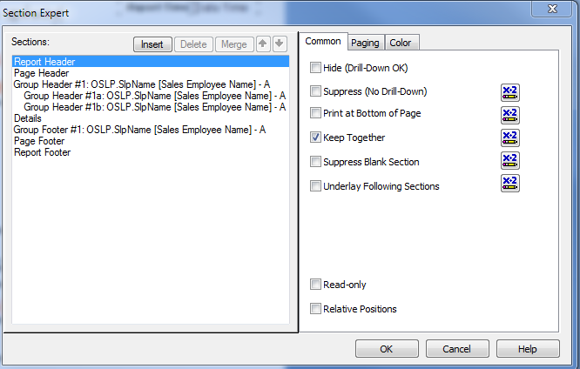
- Click on Insert>Cross-Tab and drag the cross tab box into the new header. It should look like the illustration below.
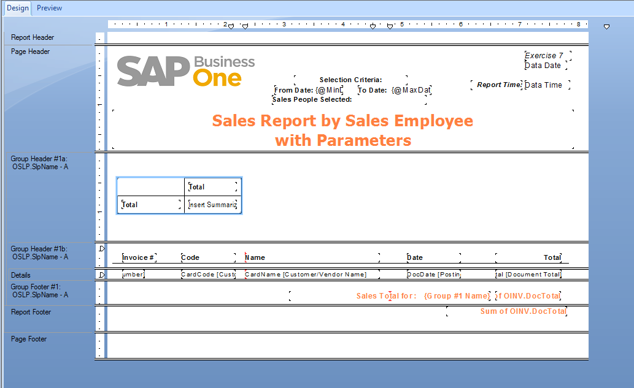
- Select The Cross Tab and right click – choosing the Cross Tab Expert – Choose fields for the Cross Tab as per the illustration below.
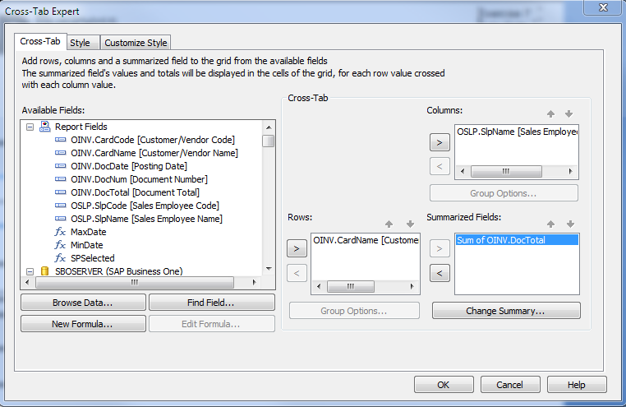
Click OK
- Your Report should now look very close to this in the Design Mode.
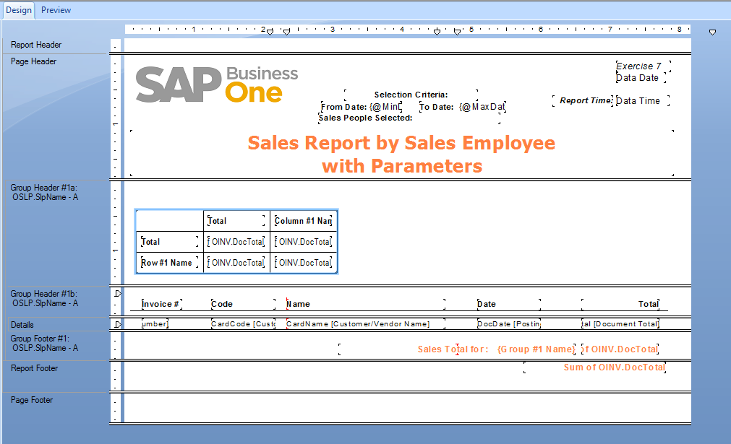
- Go to Addins>SAP Business One>Preview in SAP Business One and run the report. It should look like this in Preview Mode.
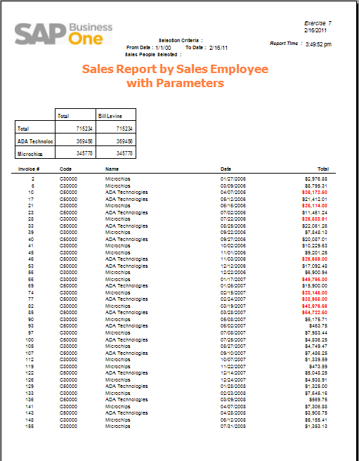
- Choose File>Save As and named the report “Example – Cross Tab Report”

Formatting the Cross Tab
- The simple way to format the Cross Tab is to choose from a template by right clicking on the upper left hand corner of the Cross Tab in Design View and once again selecting the Cross Tab Expert.
Choose the Style TAB – Choose “Honey Mustard”
- You can also further customize the style by selecting the Customize Style Tab in the Cross-Tab Expert.
- After selecting Honey Mustard as the style the Cross Tab will look like
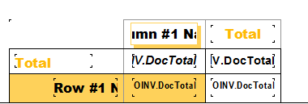
- And in Preview Mode
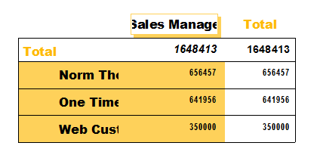

Advanced Features For The Cross Tab
Now you can choose to more carefully fit the Cross Tab to your purpose and preference by:
- In Design or Preview Mode Adjust by dragging and dropping – the size of columns and rows
- Right Clicking on numerical values and choosing to format field
- There are many additional options and formatting tools to further fine-tune your Cross Tab.
- With a little work it will look more like this
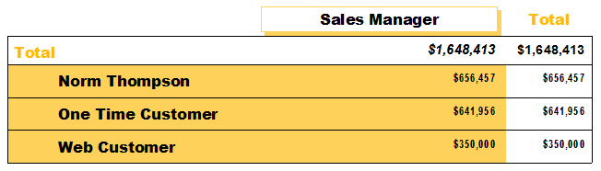
- And the Previewed report will look like
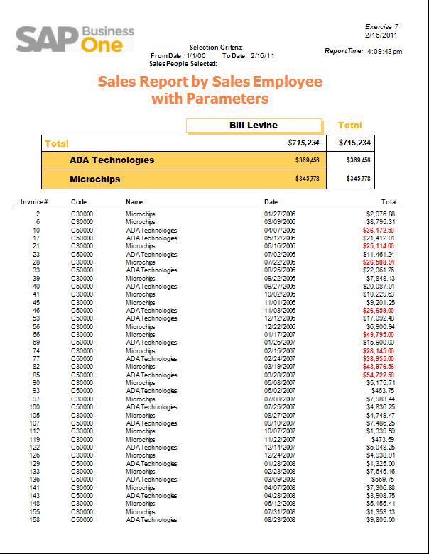

- And…each new Group will have its own distinct Cross Tab
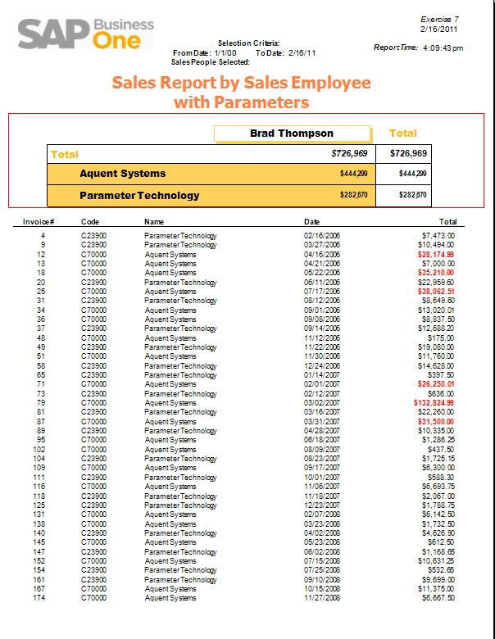
- Save You Work – File Save As” “Example - Cross Tab Report”
- Look for this report in the Sales Reports Folder in SAP Business One.

Conclusion
Cross Tabs are an effective and eye-catching means to summarize large amounts of data into easily evaluated sets of data. They are easy to create and make data and trends easier to ascertain.

The tips in this article are just the beginning when it comes to developing cross tabs for Crystal Reports. Formatting cross tabs can be tricky, and getting the correct data to summarize how you intend it to can be a frustrating task. Using the tips in this article as a starting point and with a little practice, you will be able to put the cross tab craziness to rest.

Introduction to Charts
Another powerful feature of Crystal reports is the capability to imbed context sensitive Charts and Graphs into the body of the report. These graphs and charts add a distinctively professional presentation quality into your reports. Boards of Directors, C-level Executives and managers find these illustrative snapshots of immense value. Developing the ability to add an artistic flair to your reports will add additional value to your reporting skill set.
This appendix will cover 3 elements of Charts and graphs. We cover three major areas with cross tabs in this article:
- Getting Data Into The Chart
- Formatting The Chart
- Advanced Chart Features

Getting The Data Into The Chart
In Crystal Reports open the recently saved “Example - Cross Tab Report”
- Please choose File>Save As> “Example – Charts Report”
- In Design View – Move all the items in the Page header into the currently blank Report Header – this will require re-sizing the report header.
- Insert a new Report header using the Report>Section Expert – making sure this new Report Header is below the previously created one. This new one is blank. Expand its size also.
- Choose Insert>Chart – and drag the Chart box into the new Reports Header – your report, in design view should not look as follows.
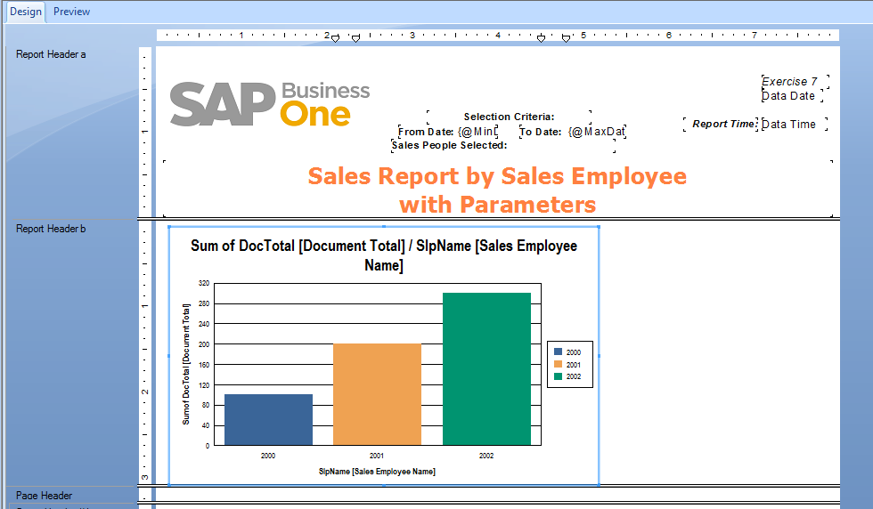
- Choose File>Save
- Right Click on The Chart and choose “Chart Expert”
The Chart Expert will have already chosen some default settings that make the most sense – in a basis sort of way. This will be easily seen in the Layout panel “groups Section. If this needs to be more specific you could choose to change it with the “Advanced: section. In this case that is not necessary.
You can click through each Tab and make more refined and logical choices as you see fit/
Data – Axes – Options – Color Highlight and Text are the available Tabs.
- The Chart Export Screen Groups section will look like this by default
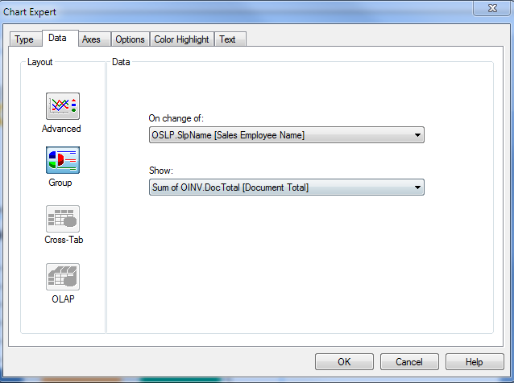
- Click Ok after you make any changes you deem necessary

Formatting The Chart
- Now right click on the Chart and choose “Format Chart” which looks like
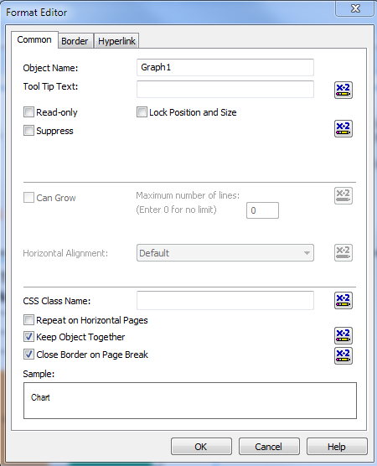
- Add Borders to the Chart in the Border Tab and the Chart will now look like…in Design View
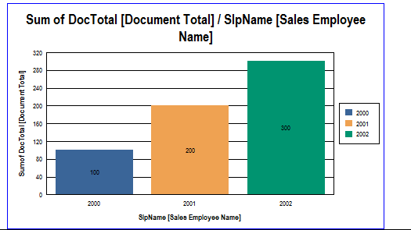
- Right Click on The Legend in the Chart and choose “Format Legend” – Go to the Layout Tab and deselect the Show Legend Check Box.
- Click On The Chart – Right Click and choose “Chart Options” – Click through each Tab and make changes that seem desirable. For instance in Titles Tab…
Delete the title entry
Replace Group Title with “Sales Rep”
Replace Data Title with “Sum of Doc Total”
- In the Appearance Tab
Choose Riser Shape :Beveled Box
Check the box for “Use Depth”
- In the Data Labels Tab
Check Show Data Labels
Center
Value
- In The Legends Tab
Choose Color Mode – “Color By Series”
- In The Gridlines Tab
Only Choose to check “Data Axes” – major gridlines
- Click OK
- The Chart in Design View will now look similar to…
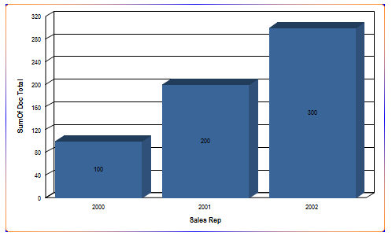

Advanced Features For Charts
- Click On any one of the value in the center of the Bar Chart to highlight the label
- Right Click and Choose “Format Label” Choose for format the value label as
White – Arial Narrow, Size 12, Bold
- Click OK
- Click on any of the vertical axis labels on the left side – then right click and choose “Format Axes Label”
Change the size to 12 and the Color to a darker blue
Click OK
- Click the horizontal labels under the bars on the bottom of the Chart
Right click and choose “Format Axes Label”
Change the size to 12 and the Color to a darker blue
Click Ok
- Click On The Outer Edge of The Chart to highlight it and then right click choosing “Format Background”
Click on Select The Gradient Button
Select a lighter blue radiant pattern
Click OK
- Select the Right Edge of the Chart and re-size the chart to fill the section right to left
- Your Chart – in the design View should like similar to…
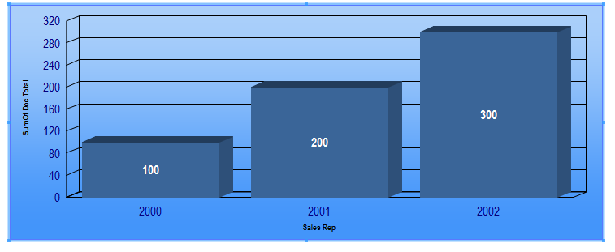
- Now Choose Addins>SAP Business One>Preview in Sap Business One
Your Preview should now look like…
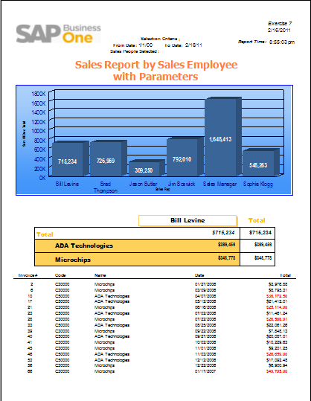
- Look for this report in the Sales Reports Folder in Sap Business One
Conclusion
Charts Can add an entirely new dimension to the dynamics of reporting. Easier to understand, professionally illustrated reports and analytics, driven by the data in the body of the Crystal Report will easily point out dynamic business realities and problems, leading to potential solutions and greater business profitability.

