Exercise 7 – Sales Report Grouped by Sales Employee with Parameters
Exercise Objectives
At the conclusion of this exercise, you will be able to:
- Add Business One Selection Parameters/Tokens to your Sales Report
- Use those parameters in the Select Expert
Exercise Introductions
We want to modify the report we built in Exercise 6 to give your user more control over the data presented in the report. So we will ask you to create some report parameters or Tokens that will prompt the Business One user to select data for their report. Then will use those parameters as Selection criteria to filter the report results.
Exercise Steps
- Open the Sales Report by Sales Employee you created in the last exercise.
- First thing before we forget, use File > Save As to save your report design as Sales Report by Sales Employee with Parameters
- Our users want to “filter” this sales report by two main criteria
  - Sales Person Name , one OR more Sales people can be selected
  - Document Date, They want to supply a range of dates for invoices in the sales report
- You need to create 2 new parameters/tokens. We want the users to run this report from a Business One menu, so we will need to make these parameters behave like Business One tokens. The first parameter will be for Doc Date: Right click and select New on the Parameter tree in the Field Explorer
  - Name: DocDates@
  - Type: Date
  - List of Values: Static
  - Prompt: Select Doc Range
  - Allow multiple values: False
  - Allow discrete values: False
  - Allow range values: True
- The second for Sales Person should be set up as follows:
  - Name: SalesPersons@SELECT SlpCode, SlpName from OSLP
  - Type: Number
  - List of Values: Static
  - Prompt: Select Salesperson(s)
  - Allow multiple values: True
  - Allow discrete values: True
  - Allow range values: False
- Save your report to your local Desktop folder again. File> Save
- Now delete the existing fields in the Select Expert – Record.
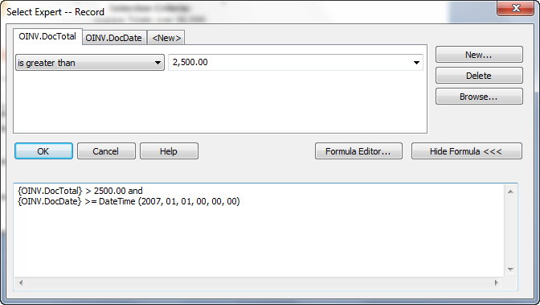
- These are left there from Exercise 6 report. These parameters where hard coded. Use the Delete button to delete both the DocTotal and DocDate selections.
- Select the New button to add a new Record Selection using your two new created parameters. When you’re done the formula should looks as follows: Click OK to save these new Selection criteria.
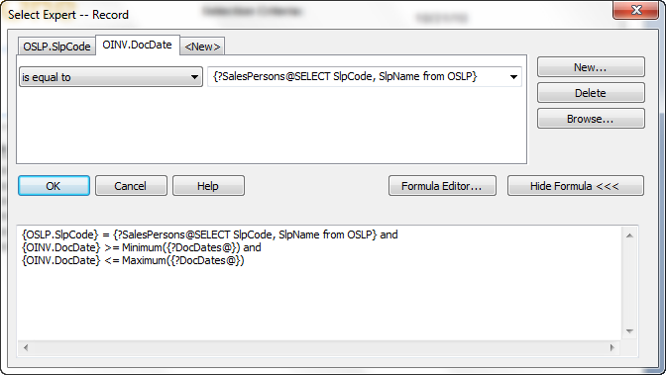
- From the Add-Ins Menu choose “Preview in SAP Business One” This should take you to Business One where if your parameters were defied right you should see:
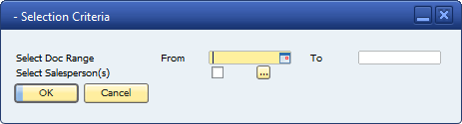
- Select your Document range with the From and To date pickers. Select one or more Sales Persons from the ellipse button and follow on Multiple Values Selection window.
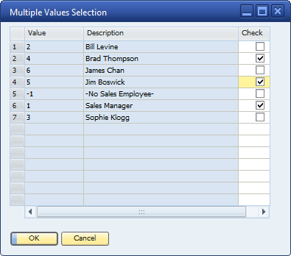
- Select OK and then OK again to run the report in Business One
- Did it work? Did it just return the sales persons you asked for?
- The users like the new report, but there is just one thing. They want a line between the “Select Doc Range” Prompt and the “Select Salesperson(s)” prompt on the Selection Criteria window in Business One. Please add that for them and re-run so it looks like this.
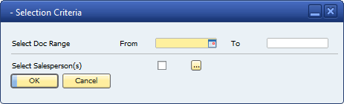
- For Extra Credit. Can you print the user’s selection criteria in the Page Header?
- OOOPS Just one more thing. The users would like to know if you can add a “switch” to the report. It they say Yes to the switch then they DON’T WANT to print the Time the report was run. Can this be done? Maybe via a Boolean parameter and Field Suppression on the Special Field Data Time and the associated label? Look like this?
